Detecting Patterns in Freely Falling Objects Name: _________________________________

On the graphic below left, you will draw the trajectories of balls that are released on the Moon and on Earth. For Section A, you will show the position of a dropped ball on the Earth (in green) and on the Moon (in blue). Using the scale along the left edge, draw the position of the ball at one second intervals. Use 1 centimeter to represent 5 meters. Neglect air resistance and use these values for the acceleration due to gravity: g_{EARTH} = 10 m/s/s and g_{MOON} = 1.6 m/s/s . Complete the chart below right to help you locate the positions over time. For Section B, the four positions of a thrown ball are shown assuming there is no gravity. You need to add the trajectory of a ball thrown at this speed on Earth and on the Moon. The respective gravitational fields will show that the ball falls toward the ground as it moves horizontally away from the cliff.

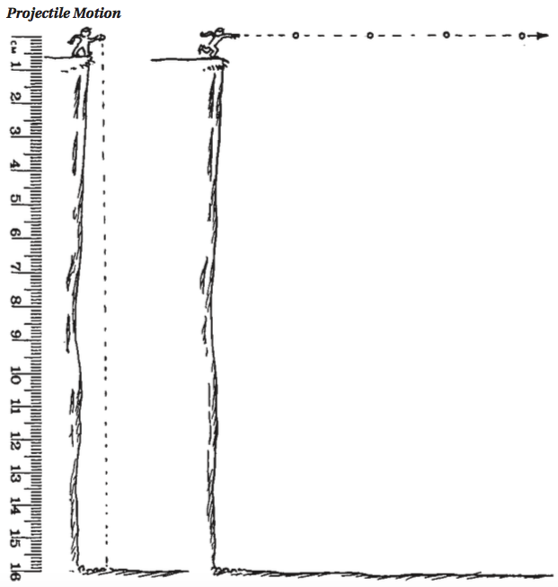
Distance fallen over time for an object in free fall:

What is the starting vertical velocity (v_{yi}) of a dropped object? ____________

What is the equation for the vertical position of a projectile? _________________________________________

If the starting position (y_{i}) and the starting velocity (v_{yi}) are zero, simplify the equation above: ______________

g_{EARTH} = ________ m/s/s g_{MOON} = ________ m/s/s

Vertical position equation on Earth: Vertical position equation on the Moon:

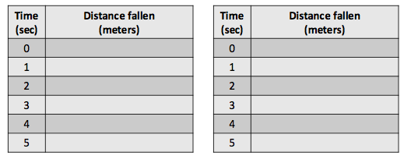
\
Describe how the distance fallen in each second changes over time. CITE DATA TO SUPPORT YOUR ANSWER.

A B

ANALYZING THE PATTERNS

Compare the last column of the tables for Earth and the Moon.

What do you notice? ______________________________________________________________

Compare the values for the GCF on Earth and the Moon. Why is the Moon’s GCF smaller?
_______________________________________________________________________________
_______________________________________________________________________________

Why do you think the last column reveals the same pattern? _______________________________
_______________________________________________________________________________
_______________________________________________________________________________

Explain the relationship between the GCF and the acceleration of gravity for Earth and the Moon.
_______________________________________________________________________________
_______________________________________________________________________________
_______________________________________________________________________________
_______________________________________________________________________________
_______________________________________________________________________________
_______________________________________________________________________________

Using what you have learned about this pattern, determine the gravitational acceleration for a planet based on the following information about a freely falling object. Between the 3rd and 4th second, the freely falling object falls 105 meters. SHOW YOUR REASONING/CALCULATIONS.

For another planet with a gravitational field strength of 50 m/s/s, how far would a freely falling object move between the 7th and 8th second after it started to fall?
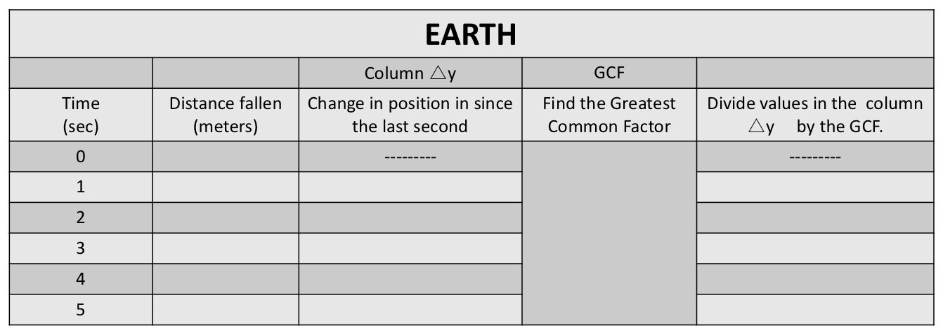
For Earth, this value will be an integer.

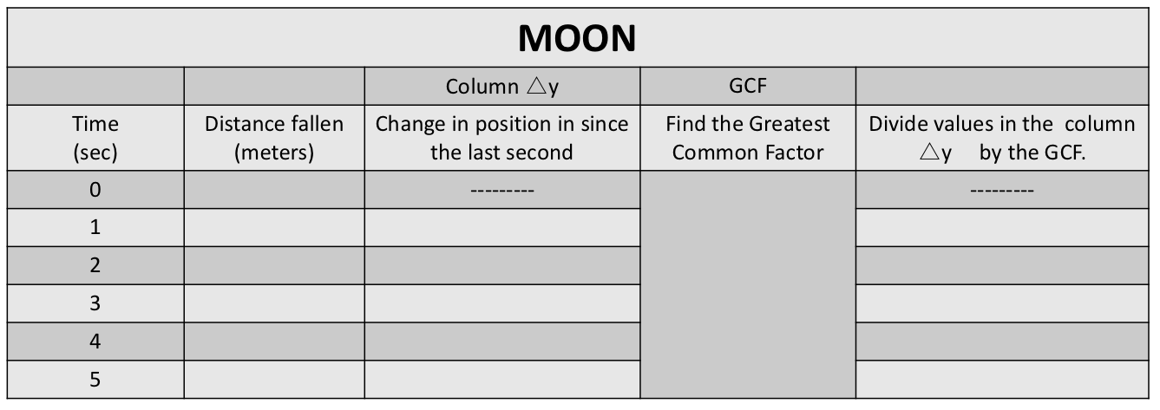
For Earth, this value will NOT be an integer.

